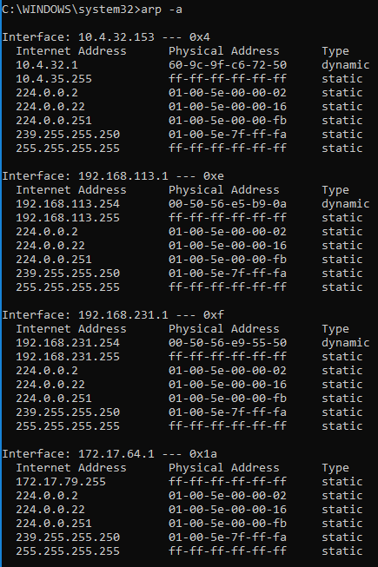
Will ping the IP 10.4.32.154, it is the next IP up from my computer’s IP 10.4.32.153
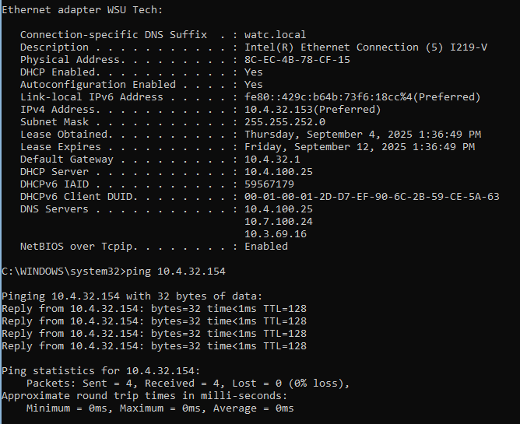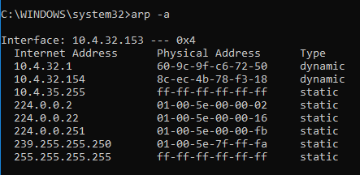
The ARP table shows who on the network has which IP by mapping it to their MAC address.
An ARP entry could be missing because a device has not yet communicated on the network, it’s IP changed and is not yet mapped to the MAC address, or the information of it was wiped from the table.
When you clear the ARP cache it removes any entries made through communication to make sure there are no stale entries and it won’t repopulate until either your computer or the other end initiates communication again to repopulate the table.
Wireshark helps visualize layer 2 communication by showing the call and response together as well as how a human would ask for the information so that it is easier to understand.

